HonorsChemistry - Unit 8: Chapter 11 – Stoichiometry
Stoich Quiz: Wednesday, Dec. 5 EQs/Problem Set Due: Friday, Dec. 7 Test Date: Friday, Dec. 7

VOCABULARY
stoichiometry | percentage yield | mole ratio
mass-mass problem | limiting reagent | excess reagent
OBJECTIVES:
- Be able to do stoichiometry problems (mass-mass problems).
- Be able to calculate the limiting reagent for a given chemical reaction.
- Be able to calculate percent yield.
- Be able to correctly use a mole ratio.
- Be able to write and balance chemical equations for use in stoichiometric problems.

MOLES

“GIVEN”

MOLES
“WANTED”

PARTICLES

Given

PARTICLES

Wanted

MASS Wanted
MASS Given
VOLUME Given
VOLUME Wanted
Mole Ratio from Balanced Equation

Guided Notetaking – Stoichiometry
- Stoichiometry
Reaction Stoichiometry – mass relationships between reactants and products in a chemical rxn.
- Mole Ratio
Mole ratio is determined from a balanced equation!
Example: 2Al₂O₃ 4Al + 3O₂

mole ratios:
Practice w/ mol to mol ratios
Example 1:
- Given this equation N₂ + 3H₂ 2 NH₃, write the following molar ratios:
  - N₂ / H₂
  - N₂ / NH₃
  - H₂ / NH₃
Example 2:
- Given the following equation: 8 H₂ + S₈ ---> 8 H₂S, write the following molar ratios:
- H₂ / H₂S
- H₂ / S₈
- H₂S / S₈

Predict the product of the following equations, balance the equations and record the mole ratios:

cobalt(II) carbonate →

zinc + hydrochloric acid →

sulfuric acid + sodium hydroxide →

- Reaction Stoichiometry Problems - “Given” and “Unknown”
**Type 1: mol to mol problems
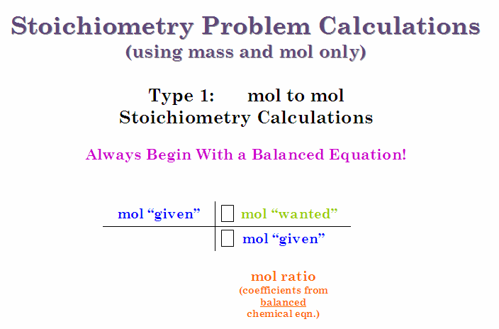
Example: Using the reaction, 2Al₂O₃ 4Al + 3O₂ how many mol of Al can be produced from 13 mol of aluminum oxide?

You Try:
4 FeCr₂O₇ + 8 K₂CO₃ + 1 O₂ 2 Fe₂O₃ + 8 K₂CrO₄ + 8 CO₂

- How many moles of FeCr₂O₇ are required to produce 44 moles of CO₂?

- How many moles of O₂ are required to produce 107.9 moles of Fe₂O₃?

- If 309 moles of FeCr₂O₇ react, how many moles of O₂ will be consumed?

**Type 2: mol to g problems
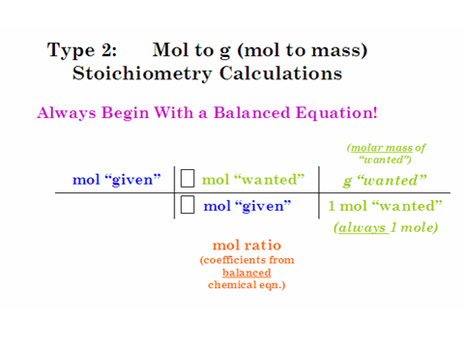
2Al₂O₃ 4Al + 3O₂

Example: Using the same reaction as above, how many g of O₂ can be produced from 13 mol Al₂O₃?

Example: Using the same rxn, how many g of Al will be produced at the same time as 3 mol O₂?

You Try:

In a reaction between the elements aluminum and chlorine, aluminum chloride is produced.
___Al + ___Cl₂ ___AlCl₃

- 2 moles of Al will react with ______ mole(s) of Cl2 to produce ______mole(s) of AlCl3.

- How many grams of AlCl3 will be produced if 2.50 moles of Al react?

**Type 3: g to mol problems

2Al₂O₃ 4Al + 3O₂

Example: Using the same rxn, how many mol of Al can be produced from 25g Al₂O₃?

Example: Using the same rxn, how many mol of Al₂O₃ will be needed to produce 25 g Al?

You try:
How many moles of salt can be formed from 12.0g of sodium reacting with Cl₂?

Given: MgCl₂ + 2 K 2 KCl + Mg How many moles of KCl can be formed from 10 g of magnesium chloride?

**Type 4: g to g problems (aka mass to mass problems)
2Al₂O₃ 4Al + 3O₂

Example: Using the same rxn, how many g of Al can be produced from 25g Al₂O₃?

Example: Using the same rxn, how many g of Al₂O₃ will be needed to produce 25 g Al?

You Try:
Given: BaCl₂ + 2 K 2 KCl + Ba How many grams of barium can be formed from 10 g of potassium?

Type 5 – molar volume of gas problems – similar to mass-mass
Example: If 10.0 g of carbon reacts with oxygen at STP, what volume of carbon dioxide can be formed?

You try:
If 8.5 L of I₂ are produced (at STP) in the following equation:
2 KI (aq) + Cl₂ (g) 2 KCl (aq) + I₂ (g)
- how many grams of KI were used?

Particle and Volume Stoichiometry

Sometimes quantities of particles or volumes are used in stoichiometry. Remember that 1 mole is equal to 6.02 x 10²³ representative particles and that 1 mole of any gas at STP (1 atm, 0°C) is equal to 22.4 L.

1 mol , 6.02 x 10²³ particles, 1 mol , 22.4 L
6.02 x 10²³ particles 1 mol 22.4 L 1 mol

Given in Particles Grams
Liters
1 mol

6.02 x 10²³ or
molar mass (g) or
22.4 L

Coefficient of Unknown

Coefficient of Given
6.02 x 10²³ or
molar mass (g) or
22.4 L

1 mol

For example: Given that 2 H₂O (g) 2 H₂ (g) + O₂ (g), how many molecules of O₂ will be produced if 2.65 x 10²⁵ molecules of water decompose?

2.65 x 10²³ molecules H₂O 1 mol H₂O 1 mol O₂ 6.02 x 10²³ molecules O₂ = 1.33 x 10²³
6.02 x 10²³ molecules 2 mol H₂O 1 mol O₂ molecules O₂

How many liters of hydrogen would be produced if 6.0 liters of water reacted completely?

6.0 L H₂O 1 mol H₂O 2 mol H₂ 22.4 L H₂ = 6.0 L H₂
22.4 L 2 mol H₂O 1 mol H₂

1) Na₂CO₃ (aq) + H₂SO₄ (aq) H₂O (l)+ CO₂ (g) + Na₂SO₄ (aq)

- If 18.0 g of water were produced, how many molecules of carbon dioxide gas were also produced? (6.01 x 10²³ molecules)

- If 2.31 moles of sodium carbonate reacted completely, how many molecules of water were produced? (1.39 x 10²⁴ molecules)

2) 2 Na + 2 H₂O → 2 NaOH + H₂

If 3.45 x 10²⁶ atoms of sodium reacted, how many molecules of hydrogen gas would be produced? (1.73 x 10²⁶ molecules)

3) P₄ (s) + 5 O₂ (g) 2 P₂O₅ (g).

- If 2.5 mole of oxygen reacted, how many molecules of diphosphorus pentoxide were produced?
(6.0 x 10²³ molecules)

b. 3.65 g solid phosphorus (P₄) reacted with excess oxygen gas, how many molecules of the product were produced? (3.55 x 10²² molecules)

4) C₁₀H₈ (g) + 12 O₂ (g ) → 10 CO₂ (g ) + 4 H₂O (g).

If 6.00 moles of oxygen reacted, how many liters of carbon dioxide would be produced? (112 L)

- Limiting Reagent (Reactant) – (LR)
- Controls the amt. of product formed
- Completely consumed in the rxn.
- “runs out” first
- Example:
People on plane 300 people; 250 seats
**Seats are the limiting factor**

Limiting Reagent Problems
- Do mass – mass (g to g) calc. for all reactants.
- Whichever reactant produces the least is the Limiting Reagent (LR)
Example: If 5.0g of hydrogen reacts w/ 5.0g of oxygen to make water, which reactant is the LR? How much H₂O is produced?

You try: Given: 2 Mg + O₂ 2 MgO
If you react 10 g of magnesium with 10 g of oxygen – what is the maximum amount of magnesium oxide that can be produced and what is the limiting reagent?

- Excess Reactant (ER)
To find the amount of excess reactant leftover after a rxn:
- Do two mass-mass (g to g) problems to find LR
- Use LR to calculate excess reactant used.
- Subtract excess reactant used from original amt. of excess reactant = leftover excess reactant
ER Example:
If 15.0g of salt (NaCl) reacts with 20.0g silver nitrate:
- How much AgCl is formed?

b) What is the limiting reagent?

c) How much of the excess reagent is left over?

If 13.0g of KOH reacts with 17.0g of Al(NO₃)₃:
a) How much KNO₃ is produced?

b) What is the limiting reagent?

c) How much of the excess reactant is left over?

- Percent Yield
- % yield = actual yield X 100%
theoretical yield
- theoretical yield:
  - maximum amt. of product
  - from mass-mass (g to g) problem
- actual yield:
  - actual amt. of product
  - from lab result; or given in a problem

Example: In lab you complete an experiment that produces 25 g of NaCl – you should have produced 29 g of salt – what is your percent yield?

You try: Given: 2 Al + 3CuSO₄ Al₂(SO₄)₃ + 3 Cu If you produce3.70 g of Cu but you should have produced 3.55 g - what is the percent yield?

Example # 2: CO + 2H₂ CH₃OH If 75.0g of CO reacts to produce 68.4g of CH₃OH, what is the % yield?

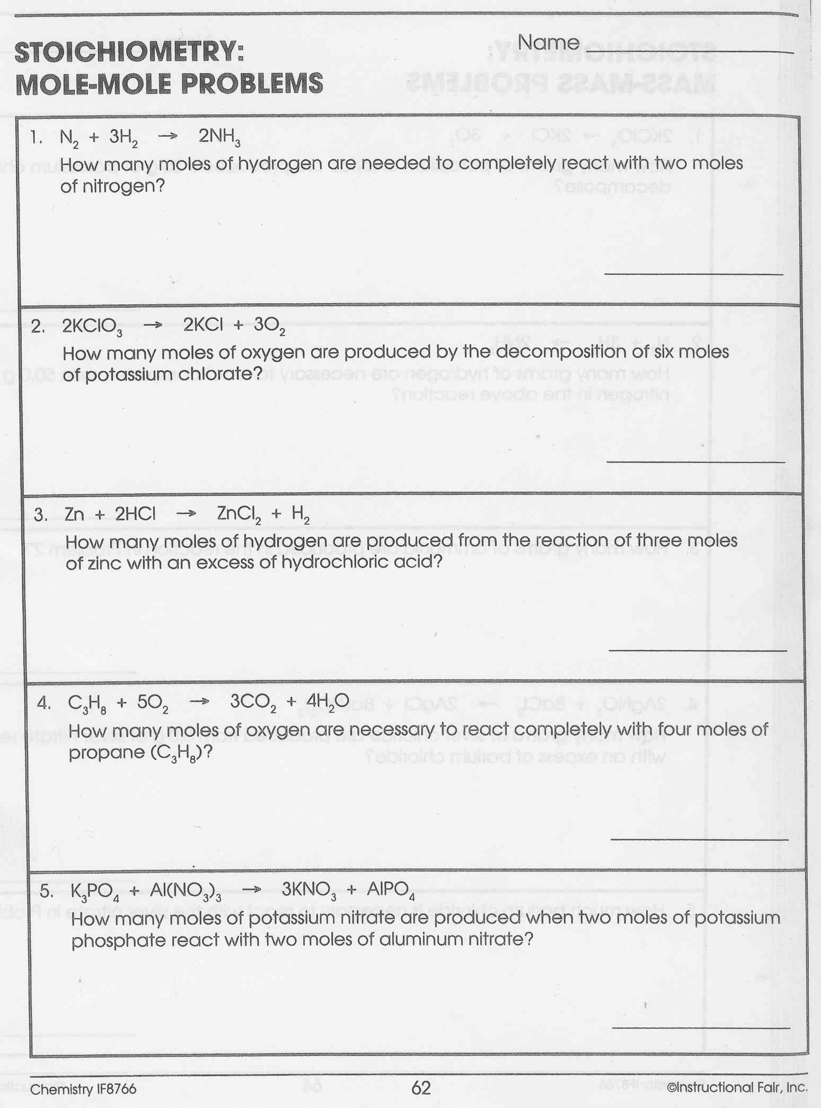
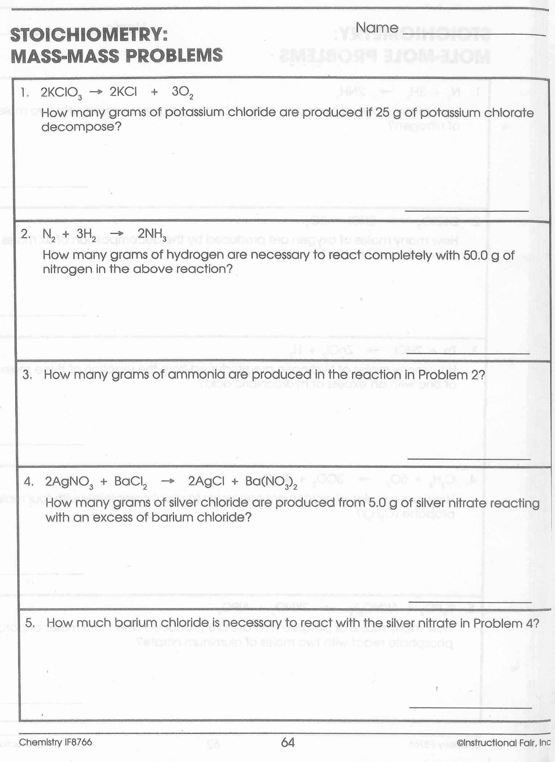

Stoichiometry Worksheet #1
Perform the following calculations. Be sure to use proper units!

Answer the following g mol and/or mol g conversion problems.

- How many g in 7.00 mol of N₂? _______

- How many g in 0.455 mol of NaCl? _______

- How many mol in 23.0 g of CaCO₃? _______

Answer questions 4-9 given the following equation.

2AgNO_{3(aq)} + Na₂CO_{3(aq)} Ag₂CO_{3(s)} + 2NaNO_{3(aq)}?

- What is the ratio of mol of AgNO₃ to mol of Ag₂CO₃? ________
- What is the ratio of mol of Na₂CO₃ to mol of NaNO₃? ________
- What is the ratio of mol of AgNO₃ to mol of Na₂CO₃? _______
- How many mol of Na₂CO₃ are required to produce 2.00 Mol of Ag₂CO₃? _______

- How many mol of Ag₂CO₃ are produced from 3.00 mol of AgNO₃? _______

- How many g of Na₂CO₃ are required to produce 1 mol of Ag₂CO₃? _______

Answer questions 10-13 given the following equation.

3BaCl_{2(aq)} + 2H₃PO_{4(aq)} Ba₃(PO₄)_{2(s)} + 6HCl_{(aq)}

- What is the mol ratio between BaCl₂ and Ba₃(PO₄)₂? _______

- Given 10.0 g of BaCl₂, how many g of Ba₃(PO₄)₂ will be produced? _______
Remember: g mol mol g

- Given 10.0 g of BaCl₂, how any g of HCl will be produced? ________

13. How many g of BaCl₂ is required to produce 20.0g of HCl? _______
Stoichiometry Worksheet #2
Perform the following calculations. Be sure to use proper units!

Write the equation for the reaction in chemical symbols when necessary, then answer the following mass-mass problems.

- (a) Write the equation for the synthesis of carbonic acid from water and carbon dioxide.

(b) Given 15.0 g of water and an excess of carbon dioxide, how much carbonic acid would be produced?

2.(a) Write the decomposition reaction for sodium chloride.

- How many g of sodium chloride will produce 19.0 g of sodium?

- How many g of chlorine will be produced from the conditions in (b)?

3. Given this equation: Al(NO₃)_{3(aq)} + 3NaOH_{(aq)} Al(OH)_{3(s}) + 3NaNO_{3(aq)}
(a) If 15.0 g of aluminum nitrate reacts completely with sodium hydroxide, what would be the resulting mass of aluminum hydroxide?

(b) Would be the resulting mass of sodium nitrate under the same conditions?

(c) How many g of sodium hydroxide would be needed to form 13.0 g of aluminum hydroxide?

4. Given 10.0 g of BaCl₂ and 10.0 g of H₃PO₄- how any g of HCl will be produced? ________

What is the limiting reagent:_______________

5. In lab you start with 45.7 L of sulfur dioxide gas and produce 155 g of sulfurous acid. How much sulfurous acid should be produced and what is your percent yield?

SO₂ + H₂O H₂SO₃

Mass of H₂SO₃ that should be produced:___________ % yield:___________

STOICHIOMETRY PRACTICE – Work problems on a separate piece of paper.

Remember: You must have correct, balanced equations to work these problems!!

- In the synthesis reaction of iron (II) with sulfur, what mass of iron is needed to react completely with 32.0 g of sulfur?

- Given: Zn + 2 HBr ZnBr₂ + H₂ ; What mass of zinc bromide can be produced from 25.0 g of hydrobromic acid ?

- Silver bromide can be precipitated by the reaction of silver nitrate with sodium bromide. What weight of precipitate can be produced starting with 34.3 g of sodium bromide?

- Hydrochloric acid is added to 50.0 g of iron (II) sulfide. What mass of hydrogen sulfide is produced?

- Given the Haber process: N₂ + 3 H₂ 2NH₃
If 3.41 g of hydrogen reacts with 2.2 g of nitrogen – what is the limiting reagent? How much ammonia is produced?

- When 25 g of calcium reacts with 25 g of chlorine, how much calcium chloride is produced?

7. In lab, you start with 128 g of sulfur dioxide to produce 150 g of sulfurous acid. How much sulfurous acid should be produced and what is your percent yield?
SO₂ + H₂O H₂SO₃

8. In the synthesis reaction of potassium with sulfur, what mass of potassium is needed to react completely with 32.0 g of sulfur? 2 K + S K₂S

Review Sheet Unit 6 - Stoichiometry

- Write a balanced equation for the reaction of aluminum nitrate with sodium hydroxide. What type of rxn is this?
2. How many g of sodium hydroxide would be needed to from 13.0 g of Al(OH)₃?
3. How many mol of aluminum hydroxide would be formed from 15.0 g of Al(NO₃)₃?
- For the decomposition of mercury (II) oxide how many g of O₂ are formed from 10 mol of HgO?
- Given: C₇H₆O₃ + CH₃OH C₈H₈O₃ + H₂O A chemist starts with 1.75 g of C₇H₆O₃ and produces 1.42 g of C₈H₈O₃ – what is her percent yield?
- Suppose a solution containing 3.50 g of sodium phosphate is mixed with a solution containing 6.40 g of barium nitrate. How many grams of barium phosphate can be formed?

Answers:
1. Al(NO₃)₃ + 3 NaOH Al(OH)₃ + 3 NaNO₃ Double displacement
2. 20.0 g NaOH 3. 0.0704 mol Al(OH)₃ 4. 160 g O₂ 5. 73.6% 6. 4.92 g

PROBLEM SET Unit 8 – Stoichiometry:

Review:
- Write balanced equations for the following reactions:
- Sodium oxide is added to water.

- A solution of lead (II) chloride is added to a solution of iron (III) sulfate

- Chlorine gas is bubbled into a solution of potassium iodide.

- C₃H₇ is burned in oxygen

- What is the molarity of 35 g of iron (II) acetate dissolved in enough water to make 250 ml of solution?

Current Unit Material

- Suppose a solution containing 3.50 g of sodium phosphate is mixed with a solution containing 6.40 g of barium nitrate. How many grams of barium phosphate can be produced?

- Octane, C₈H_{18,} is a component of gasoline.
- Write the balanced equation for the complete combustion of octane.

- How many grams of O₂ are needed to burn 5.00 g of octane?

- Octane has a density of 0.692 g/ml at 20 C. How many g of O₂ are required to burn 2.00 L of octane?

- One of the steps in the commercial process for converting ammonia to nitric acid involves the conversion of NH₃ to NO:

4 NH₃ + 5 O₂ 4 NO + 6 H₂O

- How many grams of NO form when 3.50 g of NH₃ reacts with 2.85 g of O₂?

- Which reactant is the limiting reactant and which is the excess reactant?

- How much of the excess reactant remains after the limiting reactant is completely consumed?

