**Honors Chemistry – Unit 1**

**Matter, Physical vs. Chemical Properties, Phase Change Diagrams, Heat Calculations, Enthalpy**

**Element Quiz 1:** Wednesday, Jan 9 **Vocab and Safety Quiz:** Friday, Jan. 11 **ALL SIGNED DOCS DUE! :** Friday, Jan. 11 **Element Quiz 2:** Monday, Jan. 14 **Warm Ups and PS Due:** Wednesday, Jan. 16 **UNIT TEST:** Wednesday, Jan. 16

**Vocabulary:** *(Vocab quiz will come from this list of words. Most can be found in your unit pack. Others you will need to look up in text book.)*

matter kinetic energy heat temperature heterogeneous mixture potential energy joule quantitative

homogeneous mixture intensive properties specific heat qualitative

solution extensive properties endothermic calorimeter

physical properties/changes heat of fusion exothermic precipitate

chemical properties/changes heat of vaporization element enthalpy

thermodynamics collision theory molecule catalyst

dependent variable independent variable rate of reaction reaction intermediate

kinetics rate of reaction reaction time chromatography

distillation filtration decanting vaporization

condensation deposition sublimation critical point triple point mass weight allotrope

**Formulas/constants:** *All formulas are found in Reference Pack; No need to memorize.*

## Given elements from Unit Pack p.3

q = mCΔT q = mHf q = mHv

## Supplementary Documents:

Reference Pack

**OBJECTIVES:**

* Be able to use the above vocabulary properly**. (Chm.2.1.2)**
* Be able to classify properties and changes as physical or chemical.
* Understand and apply basic laboratory safety rules.
* Be able to visually identify and correctly use lab equipment and safety equipment.
* Know the fire escape route for the classroom and other safety procedures.
* Be able to create a graph with appropriately labeled axes and an accurate graphic representation of the data.
* Be able to use the appropriate separation techniques to isolate parts of a mixture or solution.
* Be able to collect, assimilate, and draw conclusions from scientific data.

**STANDARDS:**

* Be able to interpret phase diagrams and heat curves.**(Chm.2.1.2, Chm.2.1.3, Chm.2.2.1)**
* Be able to identify the effect adding to or removing energy from a system has on the phase diagram chart or the heat curve. **(Chm.2.1.2, Chm.2.1.3)**
* Be able to differentiate between endothermic and exothermic reactions. **(Chm.2.2.1, Chm.2.2.2)**
* Be able to explain the law of conservation of energy/matter and how it applies to chemistry. **(Chm.2.2.3)**
* Be able to manipulate specific heat problems and solve problems using heat of vaporization and heat of fusion**. (Chm.2.1.2, Chm.2.1.3, Chm.2.1.4)**

**Element Quiz 1: Wednesday, Jan. 9** Aluminum – Lithium

**Element Quiz 2: Monday, Jan. 14** Magnesium – Zirconium

**ELEMENTS TO BE MEMORIZED**

* Learn **correct symbol** and **correctly spelled name**.
* Symbols have the first letter capitalized and the second letter is lower case.
* I would recommend writing your elements on note cards or using Quizlet!

|  |  |  |  |
| --- | --- | --- | --- |
| **Element Symbol/ Element Name** | **Element Symbol/ Element Name** | **Element Symbol/Element Name** | **Element Symbol/ Element Name** |
| Al Aluminum  Ar Argon  As Arsenic  Ag Silver  Au Gold  Ba Barium  Be Beryllium  B Boron  Br Bromine  Ca Calcium  C Carbon  Cl Chlorine  Cr Chromium | Co Cobalt  Cu Copper  F Fluorine  He Helium  H Hydrogen  I Iodine  Fe Iron  Pb Lead  Li Lithium | Mg Magnesium  Mn Manganese  Hg Mercury  Ne Neon  Ni Nickel  N Nitrogen  O Oxygen  P Phosphorus  Pt Platinum  K Potassium  Rb Rubidium | Si Silicon  Na Sodium  Sr Strontium  S Sulfur  Sn Tin  Ti Titanium  W Tungsten  U Uranium  Zn Zinc  Zr Zirconium |

**Introduction to Chemistry** *(1st Powerpoint Notes)*

**Branches of Chemistry**

1. _______________________; associated with _________________ compounds.

2. ________________________; associated with ________________________ compounds.

3. ________________________; associated with the __________________________ of samples.

4. ________________________; associated with the ____________________/_________________ of compounds.

5. ________________________; associated with the chemistry of _______________.

**The Scientific Method:** A logical, systematic approach to the solution of a scientific problem.

Steps in the scientific method include:

1. Making ______________________________.

2. Formulating _______________________________.

3. Testing hypothesis through _______________________________.

4. Developing ________________________ or formulating _______________.

**1. Making Observations or Identifying Problems**

When you use your senses to obtain information, you make an __________________________.

This allows you to identify a ______________ that needs to be ____________________.

**2. Formulating Hypothesis**

A hypothesis is a proposed ___________________________ for an observation.

**3. Testing Hypotheses through Experimentation**

An experiment is a procedure that is used to ____________ a hypothesis.

The experimental _______________ is critical to the __________________________ of the results.

**Experimental Design**

We should have only one ________________________ variable and one ______________________ variable.

We want to test the effect of the _______________________ variable on the dependent variable.

For example: the effect of surface area on _________________; the effect of temperature on ______________.

We often ________________ our results.

The manipulated variable will be on the _________________.

The dependent variable will be on the ___________________.

MIX

DRY

D________________________________________________________

R________________________________________________________

Y________________________________________________________

M_______________________________________________________

I ________________________________________________________

X________________________________________________________

Our results can show a ______________ relationship or an _______________/_________________ relationship.

DIRECT (______)

INDIRECT (______)

We should be careful to change only ____________ variable.

For example, use the same _______________________________ for each trial.

Conduct each trial under the same ______________________________.

We should have a ___________­__________.

This is a trial in which the manipulated variable is _______ changed—used for _____________________.

We should _______________________ the results of many trials.

To find the ___________, add the results of each trial and divide by the total number of _____________.

More trials produce better ________________________________ or results.

Results should be ____________________________________ by other scientists.

We should report _________ results, not just the __________________________ ones.

Chemists often use ____________________________ to measure such things as pH, temperature, or pressure.

The probes connect to a _________________________ and the data is graphed automatically.

Computer _____________________________ are also often used to test theories.

**4. Developing Theories**

Once a hypothesis meets the test of repeated experimentation, it may become a _______________.

A theory is a long_________________________ for ___________ something happens.

A theory may need to be _____________________ at some point in the future to explain new observations or experimental results.

**Formulating Scientific Laws**

A scientific _________ is a _________________ mathematical statement of ______________ happens.

A scientific law doesn’t try to ______________ the relationship it describes. That explanation requires a __________.



**Matter and Change Notes** *(2nd Powerpoint Notes)*

**Introduction**

Chemistry - the study of __________________and its ______________________

_____________________ - anything that has mass and takes up space

Air and smoke are examples of _________________________

Light and heat are _______________________, not matter

Mass - _________________________ of matter (numbers of atoms or molecules)

Weight - measure of ______________________________ attraction

Dependent on gravity of _______________________________

***Draw and label the particle diagrams for the three stages of matter.***

**Study of Matter**

_____________________________ of matter

_________________________________________of matter

_____________________________ properties of matter

_____________________________ changes of matter

_____________________________ properties of matter

_____________________________changes of matter

**States of Matter**

Gas - ___________________________ volume and shape

Liquid - ___________________ volume, indefinite shape

Solid - ____________________ volume and shape

Plasma – state of matter similar to gas but which _________________ a charge.

**Classification of Matter**

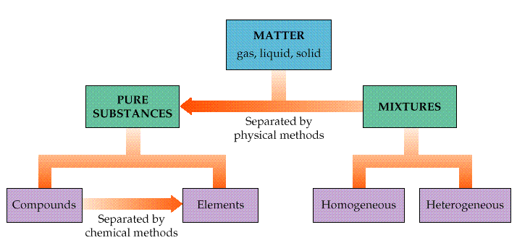

**Pure Substances**

Elements

_______________________________ form of matter / building blocks

Composed of only one type of _______________________

______________________ be simplified

Ex: Any element on periodic ______________________

Compounds

Substances that can be separated ___________ by chemical means into simpler substances

Can be written as a chemical _______________________

Ex: water, ________; baking soda, NaHCO3; ammonia, ________

**Mixtures**

2 Types: Homogeneous

Composed of only _____________ phase of matter

Completely ________________________ throughout

Also called a _________________________________

Ex: salt water, _____________________

Heterogeneous

_________________________ distribution

Ex: __________________, salad

Can be separated by _______________________means

Filtration, distillation, _________________________________

**Physical Properties of Matter** - Properties that can be observed and measured _______________ changing the composition of the substance.

|  |  |  |
| --- | --- | --- |
| Color |  | Electrical Conductivity |
| State of matter (solid, liquid, gas) |  |  |
|  | Metallic Character  (malleability, ductility& luster) | Magnetic Properties |

**Physical Changes of Matter: Changes in ___________________ not Substance**

________________________________________ are physical!!

Melting, ____________________, boiling, condensing, evaporating

Tearing, ___________________________, cutting, crushing

______________________________ is a physical change!!

**Chemical Properties of Matter**

Ability of a substance to undergo a chemical _____________________ and form a new substance

Flammability / _________________________

Acidic or basic

________________________________

**Chemical Changes of Matter**

Indicators that a chemical change ________________ have happened:

Energy is absorbed or released (temperature ____________________________)

________________________ changes *(this does not include a color dilution due to adding water)*

Gas is _________________________ (bubbling, fizzing, or odor change; smoke)

Precipitate is _______________________ - a solid that separates from solution (won’t dissolve)

Irreversibility - not easily ________________________

**Words Associated with Chemical Change**

|  |  |  |
| --- | --- | --- |
| Burn |  | Corrode |
| Rot | Ferment |  |
|  |  | ------------------------------- |

**Chemical Reactions**

______________________ substances called ________________________ change to form products.

Reactant + Reactant → ____________________________

**The Law of Conservation of Mass**

In any physical or chemical change, mass is neither created nor destroyed; it is ____________________!

In other words, the mass of the reactants will _______________________ equal the mass of the products.

**\*\* Classwork/Homework:**

**Chemistry - Matter and Its Properties**

1. Differentiate between a physical and a chemical property. Give two examples of each
2. What is the Law of Conservation of Matter?

**The four signs of a chemical change are:**

* change in __________________
* formation of a __________
* formation of a ______________________ (a solid from two solutions)
* a ___________ change (sometimes☺)

**States of Matter - Kinetic Theory** *(3rd Powerpoint Notes)*

* ______________________________ explains the states of matter based on the concept that the particles in all forms of matter are in constant _________________.

Kinetic Theory states that

* Gas particles are ___________ _______________ with no _______________ or _________________.
* Liquid particles can _________________________________ one another but do experience ________________.
* Solid particles are ________________________ to move but tend to ______________ about a fixed location.

Kinetic Energy and Temperature are ______________________ related.

* ____________________ temperature: molecules move __________________
  + intermolecular forces can’t hold them together
* ___________________ temperature: molecules move ___________________
  + intermolecular forces can now hold them together
* ____________________________ (0 K) is the temperature at which the motion of particles *theoretically* ceases.
  + 0 K = -273° C

**The Nature of Gases**

3 basic assumptions of the kinetic theory as it applies to gases:

1. Gas particles are small, hard spheres with no _______________ (compared to the volume of the container) and experience no attraction or repulsion.
2. Particles in a gas move ___________________ in constant ____________________ motion but always in straight paths, changing direction only when ______________________ with one another or other objects.
3. ______________________ are perfectly elastic. This means no _______________________________________ is lost when particles collide.

**The Nature of Liquids**

Unlike gas particles, liquid particles are attracted to each other, but they are still able to __________________ past one another.

The conversion of a liquid to a gas is called _____________________.

* When this occurs at the surface of a liquid that is not boiling, the process is called ______________________.
* _____________________ liquids evaporate at room temp. Ex. alcohols, acetone

A liquid will evaporate faster when __________________ —more kinetic energy to overcome intermolecular forces.

But…evaporation is a _____________________________________ because particles with the highest energy escape 1st!

* The **________________________** is the temperature at which the *vapor pressure of the liquid is equal to the external pressure on the liquid.*
* Since the boiling point is where the vapor pressure equals external pressure, the bp changes if the external pressure changes.
* Normal boiling point is the bp at normal atmospheric pressure or _________________.

**The Nature of Solids**

Most solids have particles packed against one another in a _________________________________________________.

* Tend to be ____________ and _________________________.

When a solid is _________________, the particles vibrate _____________ as the _______________ energy increases.

At some point, the disruptive vibrations are strong enough to overcome the strong interactions (bonds).

The **_____________________________** (mp) is the temperature at which a solid turns to liquid.

The **______________________________** (fp) is the same temperature as the mp, but indicates the liquid becoming a solid.

* Generally, most _____________________ have ____________ melting points, due to the relatively strong forces holding them together.
* Molecular compounds have relatively low melting points.





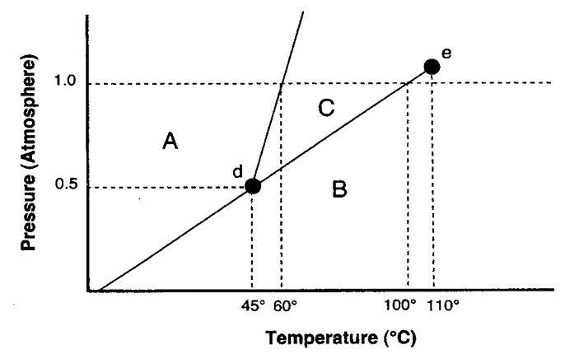

1. What **letter** represents the triple point? __________

2. What **letter** represents the critical point? __________

3. What is this substance’s normal boiling point? __________

4. What is this substance’s normal melting point? __________

5. Above what **temperature** is it impossible to liquefy this substance? __________

6. At what **temperature and pressure** do all three phases coexist? _____________

7. Would an increase in pressure cause this substance to freeze or melt? __________



**Heat Curve**

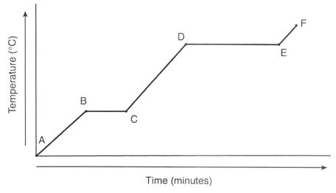

Energy being absorbed

Energy being released



**Critical Thinking**

1. Explain why food cooks faster in a pressure cooker.
2. Why is the boiling point of water lower in Boulder, CO than her in Graham, NC?
3. What is the relationship between the average kinetic energy of the particles of a substance and the temperature of that substance?
4. What is absolute zero and what is its corresponding Kelvin and Celcius temperatures?

**Classwork/Homework:**

**Phase Diagrams**

1. What section represents the solid phase? __________

**Review:**

1. Describe the 3 states of matter and illustrate a particle diagram.
2. Id the following as physical vs chemical changes:
3. Iron rusts c. ice melts
4. grass grows d. salt dissolves in water
5. Identify the following as heterogeneous mixtures, solutions (homogeneous mixtures), elements or compounds:
   1. salt water c. carbon dioxide e. sugar g. paper
   2. air d. pure copper f. water h. pizza

**Intensive vs. Extensive Properties and Endothermic vs. Exothermic Properties** *(4th Powerpoint Notes)*

Extensive properties – __________________________________________________________________

Ex. ___________________________________________________________

Intensive properties - __________________________________________________________________

Ex. ___________________________________________________________

**Chemical Changes in Matter:**

* a change in which a substance is converted into a _________________________ substance.
* Same as a _____________________________________
* Doesn’t change the amount of __________________ present
* __________________ - substances that react (or are used in the reaction)
* _________________ - substances that are formed from the reaction

**Separation Techniques:**

1. Filtration - ________________________________________________________________________________

_________________________________________________________________________________

1. Vaporization - ______________________________________________________________________________

________________________________________________________________________________

1. Decanting - ______________________________________________________________________________

________________________________________________________________________________

1. Centrifuge - ______________________________________________________________________________

____________________________________________________________________________________________

1. Paper Chromatography - _________________________________________________________________

_________________________________________________________________________________________

**Intro. to Thermochemistry** *(5th Powerpoint Notes)*

Law of conservation of energy:

* in any chemical or physical process energy is neither __________________ or _________________.
* all the energy in a process (or reaction) can be accounted for as _________________, ____________________________, or ___________.

Heat

* the _____________ that is transferred from one body to another because of temperature differences
* flows from __________________ __________________ object
  + only changes caused by heat can be detected - like changes in temperature

Units of Heat

* ____________ (J) is the SI unit of heat and energy
* ____________ ( cal) is another commonly used unit of energy defined as the quantity of heat needed to raise the temperature of ________ of water ____________.
* 4.184 J = 1 cal

Enthalpy

* Heat can be represented by either _________ or _______.
* For systems at constant pressure, the heat content, _________, is the same as a proper of the system called enthalpy, ________
* since most reactions are carried out at constant pressure _____________________________________

____________________________________________________________________.

* Changes in enthalpy = ________________
* q = ________________________________________________________

**Calorimetry**

The measurement of the _________________ into or out of a system for either ___________________ or _______________________ processes is called _______________________.

* __________________________ - the device used to measure this absorption or release of heat

System vs. Surroundings - Which way does the heat flow?

* In any chemical reaction or change of physical state, heat is either __________________ or _________________.
* In studying which direction heat flows, we use these two definitions:
  + the ___________________- the part of the universe on which you focus your attention
  + the ____________________- includes everything else in the universe

**Exothermic or Endothermic**

* Endothermic Process: ______________________________
  + Heat going into the system from the surroundings.
  + Surroundings ___________________________.
  + Example: Chemical Ice Pack
  + q or ∆H is ____________________
* Exothermic Process: _______________________________
  + Heat leaving the system and going into the surroundings.
  + Surroundings __________________________.
  + Example: Combustion
  + q or ∆H is __________________________

**Thermochemical Equations**

* A thermochemical equation shows the _________________________.
* The heat is usually given in ________and can be included in the reaction itself or directly after the equation.
* The heat change for a reaction is called __________________

**Exothermic Reactions**

* Energy is written as a product, or _____________________________________
  + CaO (s) + H2O(l) Ca(OH)2 + 65.2 kJ or CaO (s) + H2O(l) Ca(OH)2 ΔH = -65.2 kJ

**Endothermic Reaction**

* Energy is written as a reactant , or ____________________________________
  + 2NaHCO3 + 129 kJ Na2CO3 + H2O + CO2 or 2NaHCO3  Na2CO3 + H2O(g) +CO2 ΔH = 129





**Phase Changes**

* There are special names for the heat required to melt or vaporize a substance.
* The molar ___________________________________ is the amount of heat required to _________ one mole of a substance: ______________
* The molar __________________________________ is the amount of heat required to ______________ one mole of a substance: ______________

**Heating Curve**



* A heating curve is a graph that shows phase changes in

a plot of __________________ vs ________________.

* The slanted lines show heating and an increase in ____________ energy**.**
* The flat lines show phase changes and an increase in ____________________________**. (Hfus, Hvap)**

**Classwork/Homework Thermochemistry Practice**

**Specific Heat**

1. What is the specific heat of a substance if 1690 J are required to raise the temperature of a 325 g sample by 17.0 ˚C?

**Heat**

1. How much heat is required to raise the temperature of 36.8 g of silver from 16.0 ºC to 89.0 ºC? The specific heat of silver is 0.23502 J/g ºC.

**Phase Changes**

∆Hfus = 334 J/g ∆HVap = 2260 J/g

1. How much energy is needed to melt 0.25 moles of water?
2. How many joules are needed to change 2.0 g of water from a liquid at 100 ºC to steam at 100 ºC?

**Heating Curves**

Cwater = 4.184 J/g ºC

Cice = 2.05 J/g ºC

Csteam = 2.02 J/g ºC

∆Hfus = 334 J/g ∆HVap = 2260 J/g

1. How many Joules are required to raise 25.0 g of ice at 0 ºC to steam at 101 ºC?

Classwork/Homework: Specific Heat Calculations Worksheet

*(Show all work to receive credit!!)*

1. In a heat calculation problem, if the problem asks about melting/freezing you would multiply the mass times _______________________.
   1. heat of fusion
   2. heat of vaporization
   3. or specific heat
2. In a heat calculation problem, if the problem asks about a change in temperature, you would multiply the mass times ___________________ times the change in temperature.
   1. Heat of fusion
   2. Heat of vaporization
   3. Specific heat
3. In a heat calculation problem, if the problem asks about vaporizing/condensing of steam, you would multiply the mass times __________________.
   1. Heat of fusion
   2. Heat of vaporization
   3. Specific heat

|  |  |  |  |
| --- | --- | --- | --- |
| **Substance** | **Hf(J/g)** | **HV(J/g)** | **Cp(J/g°C)** |
| **Copper** | 205 | 4,726 | 0.387 |
| **Ethyl alcohol** | 109 | 879 | 2.45 |
| **Gold** | 64.5 | 1,578 | 0.129 |
| **Lead** | 24.7 | 858 | 0.128 |
| **Silver** | 88 | 2,300 | 0.233 |
| **Water (g)** | 334 | 2,260 | 2.06 |
| **Water (l)** | 334 | 2,260 | 4.18 |
| **Water (s)** | 334 | 2,260 | 2.02 |

Use the table to answer the following.

1. How many joules must be added to 10.0 g of water to raise its temperature from 10oC to 15oC?
2. How many joules are needed to heat 20.0 g of Au from 10oC to 50oC?
3. A 5.0 g piece of metal is heated to 100oC, then placed in a beaker containing 20.0 g of water at 10oC. The temperature of the water rises to 15oC. Assuming that heat lost by the metal = heat gained by the water. Calculate the specific heat of the metal.
4. How many joules are released as 5.00 g of Pb cool from 75oC to 25oC?
5. How many joules are needed to completely melt 25 g of ice at 0oC?
6. How many joules are released as 10.0 g of steam at 110oC cools to produce water at 25oC?
7. How much energy must be absorbed by 20.0 g of water to increase its temperature from 283.0° C to 303.0° C?
8. When 15.0 g of steam drops in temperature from 275.0° C to 250.0° C, how much heat energy is released?
9. You have a sample of water with a mass of 23.0 g at a temperature of -46° C. How many joules of heat energy are necessary to carry out each step? Also, please calculate the total amount of energy needed to make a time-temperature graph.
   1. Heat the ice to 0.0° C?
   2. Melt the ice?
   3. Heat the water from 0.0° C to 100.0° C?
   4. Boil the water?
   5. Heat the steam from 100.0° C to 109.0° C?

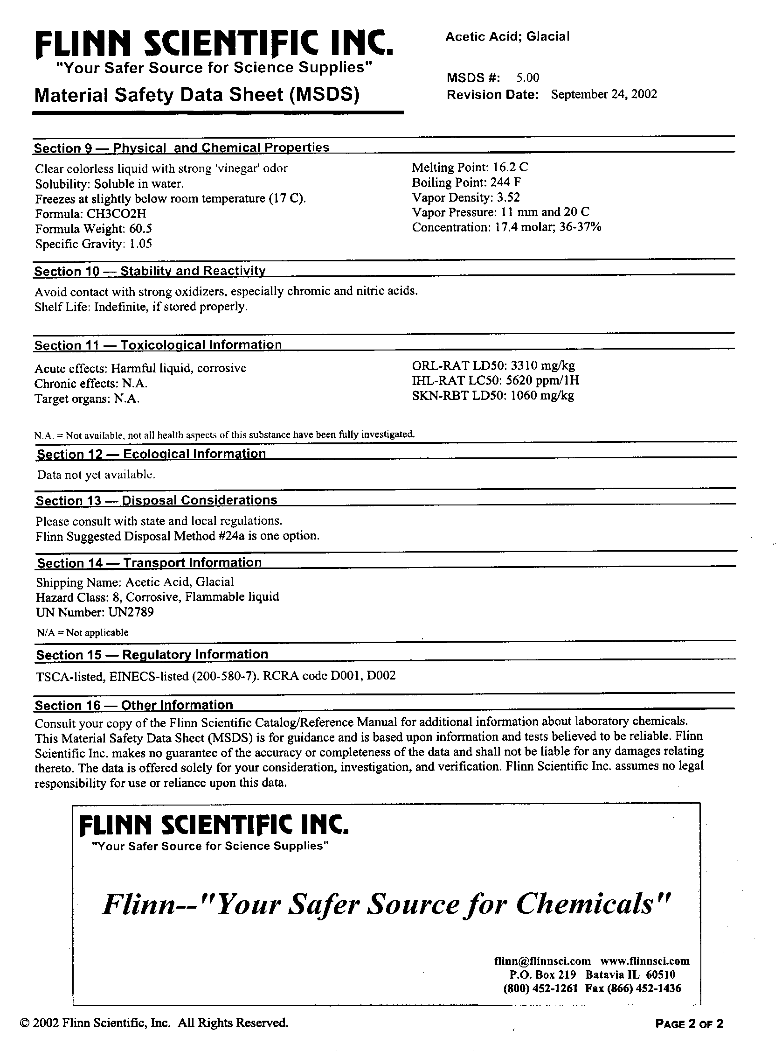

**Material Safety Data Sheet (MSDS) Worksheet**

These sheets arrive with every chemical that our school orders. Use the example provided of an actual material safety data sheet to answer the following questions. Note that the information is divided into sections, 1-16.

1. What chemical is this MSDS for? (Section 1)

2. What ***types*** of information are given about the chemical? (Section Titles—Pick 4 of the 16)

a. ______________________________________________________

b. ______________________________________________________

c. ______________________________________________________

d. ______________________________________________________

3. What are some of the health hazards involved with its use? (Section 3—List 2)

a. ______________________________________________________

b. ______________________________________________________

4. Name 3 special precautions you should take when handling and storing this chemical. (Section 7)

a. ______________________________________________________

b. ______________________________________________________

c. ______________________________________________________

5. In an MSDS, LD stands for lethal dose and LC stands for lethal concentration. LD50 is the amount of a material, given all at once, which causes the death of 50% of a group of test animals. The LD/LC is one way to measure the short-term poisoning potential of a material.

What is the lethal oral (ORL) dose for acetic acid? (Section 11) ______________________________

6. If you spill this chemical on your skin, what is the recommended first aid? (Section 4—external)

7. If you swallow this chemical, what is the recommended first aid? (Section 4—internal)

8. If you inhale this chemical, what is the recommended first aid? (Section 4—inhalation)

9. After reading about this very dangerous-sounding chemical, can you determine its household name?

(Hint: Section 2)

**Lab Equipment**

**Glassware**

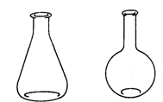

**Erlenmeyer Flask**

**Florence Flask**

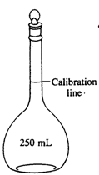

**Volumetric Flask**

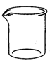

**Beaker**

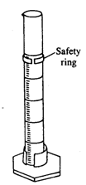

**Graduated Cylinder**

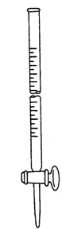

**Buret**



**Dropping Pipet**

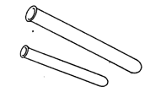

**Test Tubes**



**Watch Glass**

[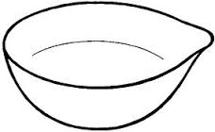](http://www.google.com/imgres?imgurl=http://www.quia.com/files/quia/users/kshiveley/Images/Evaporating_Dish&imgrefurl=http://www.quia.com/jg/2291189list.html&h=176&w=286&tbnid=nU6_gD4oJHc5kM:&zoom=1&docid=9-Y6ToWTFTBcCM&ei=v-aOVYjeLpbgoASI07CwCQ&tbm=isch&ved=0CEMQMygRMBE)

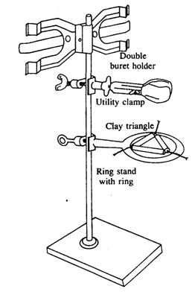

**Ring Stand**

**Ring Clamp**

**Clay Triangle**

**Utility Clamp**

**Porcelain Equipment**

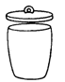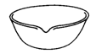

**Evaporating Dish**

**Crucible with Cover**

**Evaporating Dish**

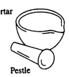

**Mortar & Pestle**

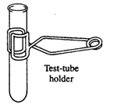

**Test Tube Holder**

**Miscellaneous Supports**

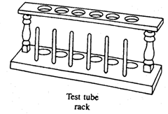

**Test Tube Rack**

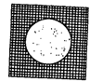

**Wire Gauze**

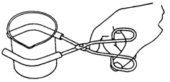

**Beaker Tongs**

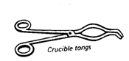

**Crucible Tongs**

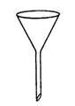

**Funnel**

**Bunsen Burner**

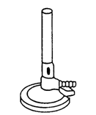

**Other Miscellaneous**



**Forceps**

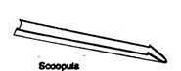

**Scoopula**



**Glass Stirring Rod**



**Thermometer**

**Rubber Stoppers**

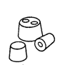

**Metal Spatula**

**Test Tube Brush**

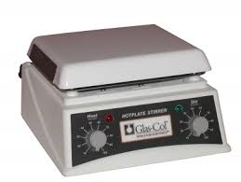

**Hot Plate**

**Wash Bottle**

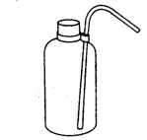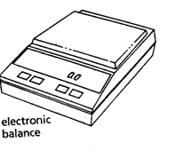

**Electronic Balance**

# **Lab Equipment Activity**

## Glassware

____ beaker to hold liquids, common sizes are 50-mL, 100-mL, 250-mL, 400-mL; may be heated; not used for measuring volume

____ Erlenmeyer flask triangular shaped flask used in titrations; may be heated; common sizes are 100-mL, 250-mL

____ Florence flask round flask used in making and for storing solutions; may be heated; common sizes are 125-mL, 250-mL, and 500-mL

____ volumetric flask flask with a long neck that has an etched mark on the neck for volume; used for making and storing solutions

____ graduated cylinder cylinder shaped container with markings used to measure volumes; may NOT be heated; common sizes are 10-mL,50-mL, 100-mL

____ test tube a simple tube of thin glass, closed at one end, for heating solutions and for holding small amounts of substances during reactions

____ buret long tube with markings and a stopcock on bottom used to measure volumes of solutions used in titrations; common sizes are 25-mL and 50-mL

____ dropping pipet glass tip with rubber bulb; used to transfer small volume of liquid

____ watch glass used to cover an evaporating dish or beaker

## Porcelain Equipment

____ crucible with cover used to heat small amounts of solid substances at high temperatures

____ evaporating dish used to contain small volumes of liquid being evaporated

____ mortar & pestle used to grind crystals and lumpy chemicals to a powder

## Miscellaneous Supports

____ test tube rack wood or plastic; used to hold test tubes in a vertical position

____ clay triangle wire frame with porcelain supports used to support a crucible over a burner

____ ring stand metal rod fixed upright in a heavy metal base; has many uses as a support

____ wire gauze used to spread the heat of a burner flame and support glassware over a flame

____ ring clamp an iron ring clamped to a ring stand support

____ utility clamp used to hold a buret or test tube and supported by a ring stand

____ test tube holder spring metal; used to hold test tubes while in use

____ crucible tongs made of iron or nickel and used to pick up and hold small items such as a crucible and lid

____ beaker tongs ends are coated in rubber and is used to hold beakers by hand

## Other Miscellaneous

____ scoopula a hybrid of scoop and spatula, it is used to transfer solid chemicals

____ forceps metal; used to pick up or hold small objects; looks like a large tweezer

____ stirring rod glass; used to stir and assist in pouring liquids

____ thermometer alcohol or mercury in glass; common range -10°C to 110°; used to measure temperature

____ funnel glass or plastic; common size holds 12.5-cm diameter filter paper

____ rubber stoppers used with test tubes or flasks to store chemicals

____ test tube brush bristles with wire handle, used to scrub small diameter glassware

____ wash bottle flexible plastic; squeeze sides to dispense water

____ electronic balance an electronic weighing device that displays mass in a digital readout

____ Bunsen burner a gas burner used in laboratories; has an air valve to regulate the mixture of gas and air

____ hot plate electrical device used to heat liquids that are contained in beakers or other glassware

____ striker a flint device used to light the Bunsen burner

**Somewhere Over The ????**

(Measuring Liquid Volume in a Graduated Cylinder)

**Purpose**: To develop skill in measuring with a graduated cylinder

To use the metric system in measuring volume

**Materials**: 3 beakers with red, blue, and yellow water

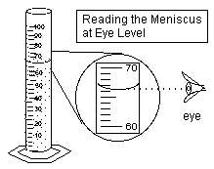6 test tubes

test tube rack

100 mL graduated cylinder

10 mL graduated cylinder

**Procedure**:

* Remember to read the bottom of the meniscus at eye level!
* Use the appropriate graduated cylinder, either 100 or 10 mL.
* Rinse the graduated cylinders between measurements.

1. Label each test tube A, B, C, D, E, and F—use pencil on the frosted glass.

2. Into test tube A, measure 19 mL of red water.

3. Into test tube C, measure 18 mL of yellow water.

4. Into test tube E, measure 18 mL of blue water.

5. ***From test tube C***, measure 4 mL and pour this into test tube D.

6. ***From test tube E***, measure 7 mL and add it to test tube D. Mix.

7. From the beaker of blue water, measure 4 mL and pour it into test tube F. Then, from the beaker of red water, measure 7 mL and add it to test tube F. Mix.

8. ***From test tube A***, measure 8 mL of water and pour it into test tube B.

9. ***From test tube C***, measure 3 mL and add it to test tube B. Mix.

**Observations and Conclusions:**

Complete the data table by listing the final colors in each test tube. Measure and record the total amount of water in each test tube.

|  |  |  |
| --- | --- | --- |
| **Test Tube** | **Color of Water** | **Total Amount of Water (mL)** |
| **A** |  |  |
| **B** |  |  |
| **C** |  |  |
| **D** |  |  |
| **E** |  |  |
| **F** |  |  |

Based on your results, complete the name of this lab: “Somewhere Over the ______________________!”

**Chromatography Lab**

**Background:**

Chromatography is a method used by scientists for separating organic and inorganic compounds so that they can be analyzed and studied. By analyzing a compound, a scientist can figure out what makes up that compound. Chromatography is a great physical method for observing mixtures and solvents. The word chromatography means "color writing" which is a way that a chemist can test liquid mixtures. While studying the coloring materials in plant life, a Russian botanist invented chromatography in 1903. His name was M.S. Tswett.

Chromatography is used in many different ways. Some people use chromatography to find out what is in a solid or a liquid. It is also used to determine what unknown substances are. The Police, F.B.I., and other detectives use

chromatography when trying to solve a crime. It is also used to determine the presence of cocaine in urine, alcohol in blood, PCB's in fish, and lead in water. Chromatography is used by many different people in many different ways.

**Purpose:**

You will separate the colors out of the black ink mark from a marking pen line on a strip of Chromatography paper. As water seeps up the paper, the molecules of color are dissolved by the solvent and carried along. They can be separated because they are in a mixture rather than being chemically combined. They will attach themselves to the cellulose in the paper, but with differing affinities depending on their chemical nature. Some cling hard; others are only weakly held. *Those that are weakly attached to the cellulose travel further up the paper than those with the stronger bond, and they will spread further.* Components in similar chemical tests, such as DNA segments in gel electrophoresis, can be identified by how far they are carried.

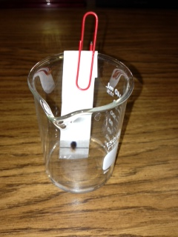**Procedure:**

1. Add approximately 5 mL of solvent (alcohol or acetone) to a small beaker.
2. Draw a line with a pencil 1 cm from the bottom of the chromatography paper strip.
3. Place a dot in the center of the line with the black dry erase marker.
4. Clip the paper strip to the beaker with a large paper clip so that the bottom of the strip touches the bottom of the beaker. You do not want the dot below the liquid line.

**Answer the following questions in your analysis portion of your lab report.**

1. What did you see? What colors were actually in the black ink?

2. Which colors were carried furthest? Which remained closest to the center?

3. What is happening when the colors move away from the center? (See the underlined section above.)

4. What causes the colors to separate? (See the italicized section above.)

5. What is this method of physical separation of a homogeneous mixture called? (Hint: What is the title of this lab?)

**Identifying Metal Ions Using Chromatography**

Paper chromatography can be used to identify metal ions in wastewater. A drop of sample solution is placed on filter paper. The bottom of the paper is set in a solvent that travels up the paper. The solvent carries the ions up the paper. Some ions move faster and therefore farther than others, resulting in a separation as they move up the paper. The paper is dried, and then stained, causing the ions to appear as colored spots. Rf values are calculated for each spot:

http://media.actstudent.org/images/rf_equation.gif

**Table 1: Rf values for 5 ions.**

| **Ion** | **Distance traveled (cm)** | **Rf** | **Spot color**  Table 2: Rf values from 3 samples of wastewater. |
| --- | --- | --- | --- |
| **Nickel (Ni2+)** | **0.8** | **0.08** | **pink** |
| **Cobalt (Co2+)** | **3.5** | **0.35** | **brown-black** |
| **Copper (Cu2+)** | **6.0** | **0.60** | **blue** |
| **Cadmium (Cd2+)** | **7.8** | **0.78** | **yellow** |
| **Mercury (Hg2+)** | **9.5** | **0.95** | **brown-black** |

| **Sample** | **Rf** | **Spot color** |
| --- | --- | --- |
| **1** | **0.60 0.78** | **blue yellow** |
| **2** | **0.35 0.95** | **brown-black brown-black** |
| **3** | **0.08 0.78 0.95** | **pink yellow brown-black** |

1. Based on the distance the ions traveled and their Rf values, how far did the solvent travel?___________

2. Based on the information in Table 1, which of the following lists the metal ions in order from the fastest to slowest speed with which they moved up the paper?

[A.](http://www.actstudent.org/sampletest/science/sci_05.html)) Hg2+, Cd2+, Cu2+, Co2+, Ni2+  [B.](http://www.actstudent.org/sampletest/science/sci_05.html)) Cd2+, Cu2+, Co2+, Hg2+, Ni2+

[C.](http://www.actstudent.org/sampletest/science/sci_05.html)) Ni2+, Hg2+, Co2+, Cu2+, Cd2+ [D.](http://www.actstudent.org/sampletest/science/sci_05.html)) Ni2+, Co2+, Cu2+, Cd2+, Hg2+

3. Based on the information in Table 2, which of the following figures best illustrates the appearance of the filter paper after Sample 1 was analyzed?

[**F.**](http://www.actstudent.org/sampletest/science/sci_05.html) 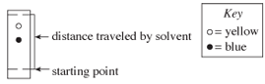 [**G.**](http://www.actstudent.org/sampletest/science/sci_05.html) 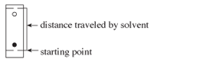

[**H.**](http://www.actstudent.org/sampletest/science/sci_05.html) 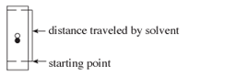 [**J.**](http://www.actstudent.org/sampletest/science/sci_05.html) 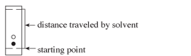

3. Why is spot color not enough information to identify a metal ion?

Label the diagram below.

D E

B C

A

Heat added

1. In which phase of matter are the molecules moving the slowest and are the shortest distance apart?
2. What are allotropes? Give examples.
3. The triple point of a substance can be defined as _______________________________________.
4. A pressure reading of 620 mm Hg is equal to how many atm and how many kPa?
5. A water bath has a temperature of 40 °C. What is the temperature in Kelvin?
6. Is evaporation a cooling process? Explain.
7. Label the diagram below.

1 atm

0 10 20 30 40

Temperature (°C)

1. What is the specific heat capacity of a substance if 2500.0 J of energy are required to increase the temperature of 35.0 g of the metal from 22.0 °C to 107.0 °C.
2. How much heat energy is required to increase the temperature of 125.0 g of water from 35.0°C to 80.0°C? The specific heat capacity of water is 4.18 J/g°C.

Unit 1 Problem Set *(Please work neatly and circle final answer. You MUST SHOW ALL WORK and include units on answers. NO WORK, NO CREDIT!!*

*Problem sets are to be completed independently and will count for a quiz grade at the end of each unit. CHEATING WILL NOT BE TOLLERATED!*

Complete each of the following questions in the space provided! If you must construct a graph you MUST use graph paper. NO HAND DRAWN GRAPHS!! Use complete sentences where needed. If you do not remember how to do a problem/question – research the answer!

1. Read the following description of the element Bromine and indicate which items are physical properties and which are chemical properties.
   * Bromine is a reddish brown liquid _________
   * Bromine boils at 58.9ºC ___________
   * Bromine freezes at -7.2ºC. ___________
   * The density of liquid bromine at 20ºC is 3.12 g/mL ___________
   * Liquid bromine readily corrodes metals. __________
   * Liquid bromine reacts rapidly with aluminum metal to form aluminum bromide. __________
2. Explain the difference between a chemical and a physical property. Be specific and use examples for each. *(May use chart or diagram.)*
3. Explain the difference between intensive and extensive properties. Be specific and use examples for each. *(May use chart or diagram.)*
4. Classify each of the following as a physical (P) or chemical (C) change:
   * Paper burning ______ d. pressurization of a gas ______
   * Ice melting ______ e. boiling water ______
   * Metal rusting ______ f. food digestion ______
5. Classify each of the following as homogeneous or heterogeneous mixtures:
6. Iron ore ______ d. soft drink ______
7. Gold bar ______ e. chex mix ______
8. Granite ______ f. mud ______
9. If the temperature of 34.4 g of ethanol increases from 25 °C to 78.8 °C, how much heat has been absorbed by the ethanol? Is this reaction endothermic or exothermic? *The specific heat of ethanol is 2.44 J/(g×°C*
10. Graphite has a specific heat of 0.709 J/(g×°C). If a 25 gram piece of graphite is cooled from 35 °C to 18 °C, how much energy was lost by the graphite? Is this reaction endothermic or exothermic?
11. Heat energy was added to a substance. The rate of temperature change is shown on the graph below.

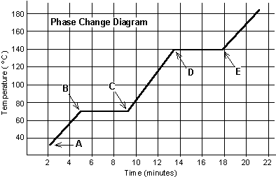

1. What process is occurring between points B and C when energy is added to the system? ______________________________
2. What phase is the substance between points C and D? ____________________________
3. At what point on the graph did the substance completely vaporize into a gas? ______
4. How long did it take for the substance to change from a solid to a gas (in minutes)? ____________
5. Heat energy was added to the substance between points B and C. Why did the temperature not change for 4 minutes? _______________________________________
6. Is this substance water? ______________ Explain your answer in detail. ________________________

_________________________________________________________________

[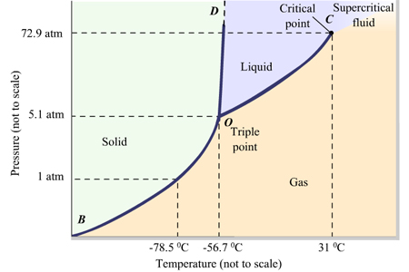](http://www.google.com/url?sa=i&rct=j&q=&esrc=s&source=images&cd=&cad=rja&uact=8&ved=0CAcQjRw&url=http://www.chegg.com/homework-help/questions-and-answers/phase-diagram-pressure-temperature-graph-shows-ranges-temperature-pressure-phase-stable-ph-q4139861&ei=sRWPVfSeOM2nyATztb7QCQ&bvm=bv.96783405,d.cGU&psig=AFQjCNFO-N6tT5XIQWwRkdHx1qtMWbvF9g&ust=1435526955710093)

1. At 1 atmosphere and room temperature (25°C), would you expect solid carbon dioxide to melt to the liquid phase, or sublime to the gas phase? ________________________________.
2. Some industrial processes require carbon dioxide. The carbon dioxide is stored onsite in large tanks as liquid carbon dioxide. Assuming we lived at sea level (1 atm), how could carbon dioxide be liquefied? (Be specific!)
3. How many joules of energy are needed to melt 36 g of ice at 0°C? (Show all work!)
4. Calculate the quantity of heat needed to warm water from 25.0° C to 95.0 ° C to prepare a 250 mL cup of coffee.
5. A piece of gold weighing 35.0 g absorbs 185 J of heat energy when its temperature increases by 41.0° C. What is the specific heat of gold?0

**Using the following data, create a graph of the data. Be sure to use graph paper!!**

|  |  |
| --- | --- |
| **Pressure (torr)** | **Volume (mL)** |
| 760 | 29.0 |
| 960 | 23.0 |
| 1160 | 19.0 |
| 1360 | 16.2 |
| 1500 | 14.7 |
| 1650 | 13.3 |

1. If you trap a sample of air and measure its volume as *you change the pressure* (while keeping the temperature constant), you can determine a relationship between volume and pressure. Answer the questions below based on the following sample data.
2. Is this a direct or inverse relationship? __________________________
3. Which is the dependent variable? _________________________
4. On a piece of graph paper, sketch a graph. (Remember DRY MIX.) Credit will not be given if graph paper is not used!
5. Why would it be important to keep the temperature constant in this experiment? (Answer using complete sentences.)