Chemistry
Study Guide – Unit One
- For each of the following, underline the independent variable, circle the dependent variable, and put a square around any controlled variables
  - A study was done to find if different tire treads affect the braking distance of a car.
  - The amount of pollution produced by cars was measured for cars using gasoline containing different amounts of lead.
  - Four groups of rats are first massed and then fed identical diets except for the amount of vitamin A they receive. Each group gets a different amount. After 3 weeks on the diet, the rats’ masses are measured again to see if there has been a decrease.

- In the following observations, circle the qualitative measurements:
  - 29 degrees Celsius
  - Water rose a bit
  - The solution turned pink
  - 37.5 mL

- Write the following numbers in scientific notation, or as normal numbers.
  - 0.00384
  - 38,000
  - 1.69x10³
  - 8.03X10⁻⁵

- A liquid has a mass of 2.50 grams and a volume of 1.93 mL.
  - What is it’s density?
  - Will it sink or float on water?

- In the space to the right, draw a scenario of
  - Both accurate and precise
  - Precise but not accurate
  - Neither accurate nor precise

- Make the following metric conversions:
  - 390 km → m
  - 0.05 cg → mg
  - 1.49 mL→ L

- Count the number of significant figures in the following values:
  - 130
  - 13.02
  - 0.0035
  - 0.00890

- Carry out the following calculations to the correct number of significant figures.
  - 15.9 + 2.703
  - 30 x 4.5
  - 16.0 – 0.07
  - 25 / 38.9

- Read the following pieces of lab equipment with the correct number of valid digits:
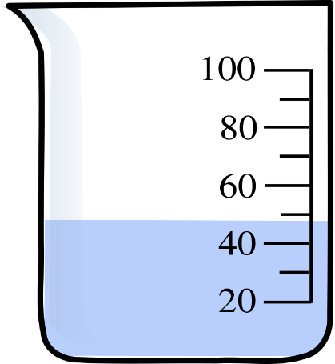 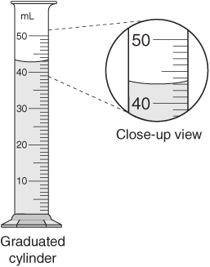

- Write the SI units for the following:
  - Temperature
  - Mass
  - Length
  - Volume
  - Time

- Describe the difference between chemical and physical properties in your own words.

- Which of the following are chemical changes:
  - Rusting
  - Changing shape
  - Melting
  - Reacting with an acid
  - Spoiling
  - Condensing

- Write two indicators that a chemical reaction has taken place:

- What physical property does distillation use to separate mixtures?

- What physical property does filtration use to separate mixtures?

- Other things you should know:
  - Know the parts of the scientific method.

  - Know the difference between heterogeneous and homogeneous mixtures.

  - Be able to describe pure substances, elements, mixtures, and compounds.

