o Physical Science Daily Warm-Ups
Speed, Velocity & Acceleration
- Answer the questions each day during the first 10 minutes of class.
- You MUST SHOW ALL WORK for calculations and answers must have units!! (No work; No credit)
- If you are absent, you must make-up the missed questions the day you return.
Score
- Write the correct answers for any questions you missed.
- Turn in this assignment with your unit pack at the end of each unit.
 | Daily Warm-Ups:
Day 1 | What is speed?  What is the formula used to calculate speed/velocity? Give formula and provide a key for each of the variables. Indicate the units used for each variable.
Day 2 | If a car travels 500 m in 7 seconds, how fast is it going? (Show your work!)  How much time will it take for an ant to travel 10 m across the forest floor if it is traveling at a pace of 0.5 m/s?
Day 3 | 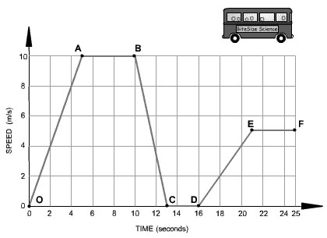  Choose the correct words from the following list to describe the motion during each segment of the journey to fill in the blanks.  - accelerating  - decelerating  - constant speed  - at rest  Segment 0-A The bus is ______________________________. Its speed changes from 0 to 10 m/s in 5 seconds.  Segment A-B The bus is moving at a __________________________________of 10 m/s for 5 seconds.  Segment B-C The bus is ____________________________________. It is slowing down from 10 m/s to rest in 3 seconds.  Segment C-D The bus is __________________________________. It has stopped.  Segment D-E The bus is _______________________________________. It is gradually increasing in speed.
Day 4 | What is acceleration?  Explain the difference between positive acceleration and negative acceleration. (Give an example of each.)  What is the formula used to calculate acceleration? Give the formula and provide a key for each of the variables. Indicate the units used for each variable.
Day 5 | While traveling along a highway a driver slows from 24 m/s to 15 m/s in 12 seconds. What is the automobile’s acceleration? (Remember that a negative value indicates a slowing down or deceleration.)  A cart rolling down an incline for 5.0 seconds has an acceleration of 4.0 m/s². If the cart has a beginning speed of 2.0 m/s, what is its final speed?

