Honors Chemistry – Unit 6 The Mole

Vocab Quiz: Monday, April 15 Mole Calculation Quiz: Monday, April 15
Unit 6 Test: Wednesday, April 17
Vocabulary:
molecular mass formula mass hydrate Avogadro’s number
mole Molarity percent composition empirical formula molecular formula formula unit ionic compound molecular compound

Formula/Constants:
Molar mass conversion Molar volume conversions *Avogadro’s number *Molarity

Objectives:
- Be able to perform math functions using correct scientific notation.
- Be able to find molecular/formula mass using the periodic table.
- Be able to calculate Molarity.
- Be able to calculate percent composition.
- Be able to use molar volume in problems
- Be able to determine empirical and molecular formulas using lab data.
Percent to mass; mass to mole; divide by small; multiply to whole!
- Understand the mole and Avogadro’s number.
- Be able to convert to/from atoms, ions, molecules, moles, liters and grams.

Guided Note-Taking for THE MOLE!
What is a mole?
- “Official Definition”
  - the amount of a substance that contains as many particles as there are atoms in exactly 12g of carbon-12
- A mole is a counting unit
  - just like a dozen
  - other examples…..

Avogadro’s Number
- Constant
- the number of particles in exactly one mole of a pure substance
1 mol = 6.02 X10²³ of anything
But most often the mole is used with atoms, ions, formula units or molecules

Examples of Conversion Factors:
1 mol 1 mol
6.02 X 10²³ molecules 6.02 X 10²³ atoms, ions
or formula units

Molar Mass
Mass in g of 1 mole of anything
For an element, the molar mass is equal to the atomic weight from the periodic table.
1 mol
atomic wt. (g)

Molar Mass Examples: 1 mol C and 1 mol I
12.0 g C 126.9 g I

You try:
1 mol Ca 1 mol Fe
____ g Ca _____ g Fe

Now, you have two conversion Factors for a mole…..
Avogadro’s number Molar mass
1 mol and 1 mol
6.02 X 10²³ atoms, ions, ? g
formula units, or molecules

Example 1 How many g in 2.0 mol of He?

Example 2 How many moles in 3.01 X 10²³ atoms Ag?

Example 3 What is the mass of 1.20 X 10²¹ atoms of Cu??

You try: A. Convert 21.5 g B to moles B B. Convert 8.0 X 10²¹ atoms of Ag to g

Formula Mass/Molecular Mass/Molar Mass = Sum of masses in a compound

Example: Molar Mass of K₂SO₄

Example: molar mass of Li₂S ∙ 3 H₂O

You try: Molar Mass of Ca(NO₃)₂

These can be used as conversion factors!

1 mol MgCl₂
95.21g MgCl₂

Example: How many mol in 127g barium chloride?

You try: How many molecules in 32 g of nitrogen dioxide

Notes on Molar volume:
At STP (standard temperature and pressure = 1 atm and 273 K), one mole of any gas has a volume of 22.4 L. This is called molar volume and can be used as a conversion factor. 1mol gas or 22.4 L
22.4 L 1 mol gas

Example problem: Convert 5.0 moles of Hydrogen gas (H₂) to L.

Example two: Convert 2.2 L of ammonia gas NH₃ to g.

You try:
- Convert 1.6 moles of O₂ gas to L.

- Convert 5.0 g of Ozone, O₃ to liters.
Guided Note-Taking on Percent Composition
Percent composition is the percent by mass of each element in a compound.
Percent composition is the same, regardless of the size of the sample.

Percent Composition Calculations
% comp = mass of element X 100% = % element in the compound
molar mass of cmpd

Example: Find the % composition of Cu₂S
- Find the molar mass

- Next, find the % of each element

- Next, check your work – do the % s add up to 100?

Example 2 : Find the percent of water in Li₂S ∙ 3 H₂O

You try:
- barium chloride

2) sodium phosphate

3) percent water in CuCl₂ •5 H₂O

Guided Note-Taking on Empirical Formulas

Empirical Formula = Simplest Formula

Ex: A compound contains the elements iron and chlorine in a ratio of 1 iron: 2 chlorine – what is the empirical formula?

To find the empirical formula from data:
- Assume 100 g sample; change % to grams for each element
- Find moles from the grams of each element
- Find the smallest whole # ratio by dividing by the smallest number of moles
- If necessary, multiply to get rid of fractions.

A little rhyme to help you remember the steps:
Percent to mass Mass to mole Divide by small Multiply 'til whole

Example 1: A compound is 78% B and 22% H. What is the empirical formula?
First, change % to grams and find moles:
Next, divide all mole numbers by the smallest number of moles:
Finally, use these whole numbers as the number of each individual element. They are the subscripts.

Example 2: a hydrate is composed of 19.2 % sodium, 13.3 % sulfur and 67.5 % water – find this compounds empirical formula

Example 3: Analysis shows a compound to contain 26.56% K, 35.41% Cr, and 38.03% O. Find the empirical formula of this compound:
First (always!) assume 100g sample, convert % to g and then find moles of each element.
Next, Conversion to moles:
Next, divide all numbers by the smallest whole number to find the smallest whole number ratios:

IMPORTANT!!
- So, if you have: multiply all by:
.25 or .75 4
.33 or .66 3
.50 2 (this is the only type we will do)

You Try: What is the empirical formula if we have a sample containing 66.0% Ca and 34.0% P?

You Try: Find the empirical formula of a compound with 32.38% Na; 22.65% S; and 44.99% O.

Practice:

Molecular Formula Molecular Formula = Actual Formula
Example: C₂H₆ CH₃
molecular empirical

MF = (EF)x where X = Molecular mass
Empirical mass

Example:
The empirical formula of a compound was found to be 2 phosphorus to 5 oxygen. Experimentation shows that the molar mass of this compound is 283.89 g/mol. What is the compound’s A. empirical formula? B. molecular formula?

You try: The empirical formula of a compound is CH₆O – the molar mass of the compound is 180 – what is the molecular formula?

Guided Note-Taking on Moles in Solution (Molarity)
Molarity is the term used for moles dissolved in solution
Symbol for Molarity = M
Definition – moles of solute per liter of solution
Formula M = moles solute (mol) In ref packet
liter solution (L)
Example 1: What is the molarity of a 0.5L solution containing 2 moles of NaCl?

Example 2: What is the molarity of a 250 mL solution containing 12.7 g of lithium bromide?

You try: 1) Calculate the M of a 700. mL solution of 23.2g calcium chloride

- What is the molarity of a 0.25 L solution containing 0.55 moles of potassium nitrate?

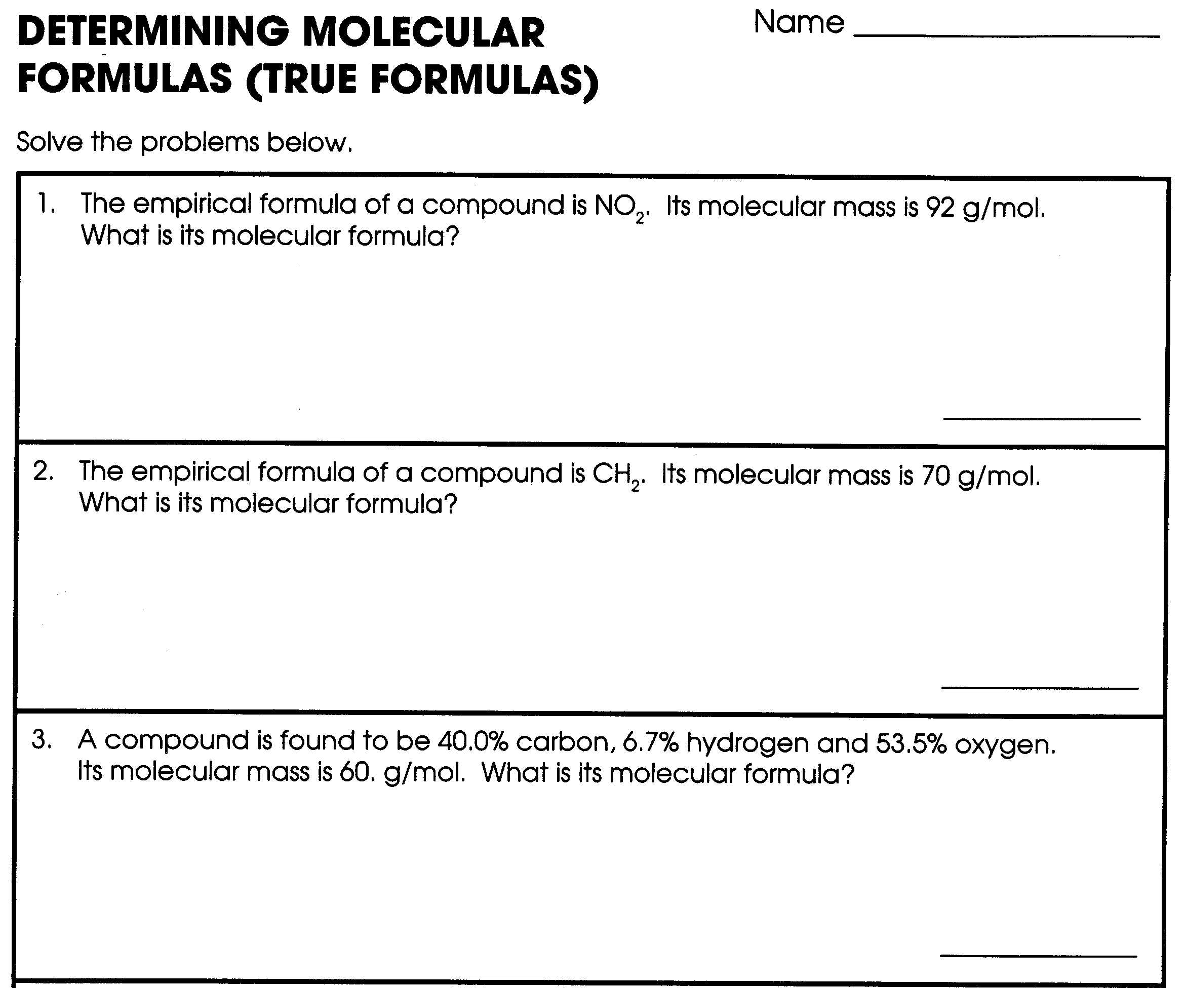

CONVERSION WORKSHEET
- Convert the following:
- 1.20 x 10²⁵ atoms of N to moles

- 11.5 g of carbon to moles

- 1.00 x 10²⁴ atoms of Thallium (Tl) to grams

- 3.01 x 10 ²³ atoms of Mg to moles

- 2.1 g of Ni to atoms

- 0.400 moles of Cd(IO₃)₂ to formula units

- 76.0 g of Ca to moles

- 46.0 g of potassium nitride to formula units

- 1.00 x 10²³ formula units of CsBr to grams

- 3.00 liters of Cl₂ to grams

- 9.30 moles of carbon dioxide to liters

- 8.00 x 10¹⁹ formula units of copper (II) sulfate to grams

Composition of Hydrates Practice sheet:

- What percentage of water is found in CuSO₄•5 H₂O?

- What percentage of water is found in Na₂S •9 H₂O?

- A 5.0 g sample of a hydrate of Ca(NO₃)₂ was heated, and only 1.7 g of the anhydrous salt remained. What percentage of water was in the hydrate?

- A 5.0 g sample of Cu(NO₃)₂ •n H₂O is heated and 3.9 g of the anhydrous salt remains. What is the value of n?

Extra hydrate practice: Solve the following problems. Show work to support your answer.
1. What is the percentage of water in the following hydrate: Cu(OH)₂ * 4 H₂O ?

2. A hydrate of magnesium sulfate has a mass of 13.52 g. This sample is heated until no water
remains. The MgSO4 anhydrate has a mass of 6.60 g. Find the formula and name of the hydrate.

3. When 5.00 g of FeCl3 · xH2O are heated, 2.00 g of H2O are driven off. Find the chemical formula and the name of the hydrate.

4. A sample of the hydrate of sodium carbonate has a mass of 8.85 g. It loses 1.28 g when heated.
Find the formula and the name of the hydrate.

- A hydrate is determined to be 45.43% water and 54.57% CoCl2. Find the chemical formula and name for this hydrate. (*Hint – assume that there is 100 g total of hydrate compound.)

Practice Sheet - Empirical, Molecular, and Molarity
- Analysis of a sample of sulfuric acid shows it to contain 0.17 g of hydrogen, 2.82 g of sulfur, and 5.67 g of oxygen. What is the empirical formula for this compound?

- Analysis of a salt results in the following composition: 3.47 g of Na, 2.12 g of N and 7.27 g of oxygen. What is the simplest formula of this salt?

- A barium salt is found to contain 21.93 g of barium, 5.12 g of sulfur and 10.24 g of O. What is the empirical formula?

- A compound contains: 26.7 % C, 2.2 % H and 71.1 % O. The molecular weight of the compound is 90. What is the compound’s molecular formula?

- A certain compound contains only C, H, and O. If 54.6 % is C and 9.0 % is H and the molecular weight is 176, what are the compounds empirical and molecular formulas?

- The percentage composition of ethane gas is 80.0 % C and 20.0 % H. The molecular weight for ethane is 30. What is the molecular formula for this compound?

- What is the M of 32.3 g of calcium chloride in 750 ml of solution?

REVIEW
- How many liters are present in 115 g of nitrogen dioxide?

- How many molecules in 0.943 moles of water?

3. How many formula units in 64.3 g of lithium sulfate?

- What is the molarity of 9.94 g of cobalt (II) sulfate in 250. ml of solution?

- How many moles of platinum are equivalent to 1.20 x 10²⁴ atoms?

- What is the percentage of nitrogen in urea, CO(NH₂)₂?

- A compound contains 27.3 g of C and 72.7 g of O. What is the empirical formula for this compound?

- A compound is 13 % Mg and 87 % Br - What is the compound’s empirical formula?

- A compound with a formula mass of 34 is found to consist of 0.44 g of H and 6.92 g of O. Find its empirical formula and molecular formula

Lab on Percent composition & Hydrates

Objective: You will study both hydrates and percent composition through proper lab techniques. Using data gathered during the lab, you will calculate the percent of water in a hydrate.

Equipment: For your pre-lab assignment make a list of the equipment you will be using.

Procedure:
Finding the percentage of water in copper (II) sulfate that is hydrated.
- Determine and record the mass of an empty evaporating dish using the balance.
- Get about 2 - 5g of copper (II) sulfate from Mrs. H. You will subtract to find the exact mass.
- Place the sample in the evaporating dish. Determine and record the mass of the evaporating dish and sample.
- Place the evaporating dish on a wire gauze over your Bunsen burner.
- Heat the evaporating dish w/ the sample.
- Continue heating until the sample turns entirely white.
- Using tongs remove the dish from the wire gauze.
- Turn off the hot plate and allow the sample to cool for 3 - 5 minutes.
- Determine and record the mass of the anhydrous sample and dish.
- Add a few drops of water to the cooled sample and note observations.
- Clean up by disposing of the sample in the trash – rinse out the dish and wipe it dry.

Data Table: Mass of evaporating dish _______________

Mass of evaporating dish and copper (II) sulfate ______________

*Mass of copper (II) sulfate used (before heating) _________________

Mass of evaporating dish and copper (II) sulfate (after heating) ______________

*Mass of anhydrous copper (II) sulfate (after heating)___________________________

* These masses are not measured during lab they will be calculated after completing the lab.

Calculations
1. Calculate the mass of copper (II) sulfate used in the lab (before heating). Write this mass on your data table.

2. Calculate the mass of anhydrous copper (II) sulfate after heating. Write this mass on your data table.

3. Subtract the mass of the copper (II) sulfate hydrate after heating from the mass of the hydrate before heating to find the mass of water in your hydrate sample.

4. Calculate the % of water in the Copper (II) sulfate when hydrated. Hint: this will involve the mass of water you found above and the mass of the hydrate before it was heated.
5. Calculate the % of copper (II) sulfate (before heating the sample).

6. Using the answers from 4 and 5 determine the formula for the copper (II) sulfate hydrate – ie how many waters will the formula contain. Hint look at the example on page 4/5 of this packet. SHOW WORK

Fill in the # of water molecules in the final formula here: CuSO₄ ● _____ H₂O

Write the name of your final compound here: ______________________________

Questions: Must answer in complete sentences with detail.
- Was the copper (II) sulfate change, physical or chemical? Explain.

- Why did we add water to the white copper (II) sulfate at the end of the experiment?

Error Analysis: List two possible errors and their effect on the lab.

#1

# 2

Unit 5 Moles Problem Set
Show all work – include appropriate units on final answers!
- You do a lab and find the molar mass of a compound to be 55 g/mol the correct molar mass is 62 g/mol what is your percent error?

____________________

- Write the noble gas configuration, and dot diagram for:

- Co

- P

- Ar

- Using the above electron configuration explain why argon does not normally form compounds.

- In the following groups of atoms which has a larger atomic radius? Explain why (do not write because it is further left and/or down on the PT)

- Li, Na or K larger:__________

Because:

- Na, Al or S larger:____________

Because:

- H, H⁺¹ or H⁻¹ larger:____________

Because:

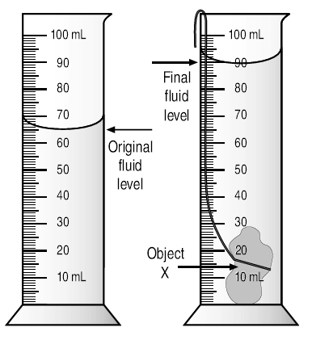

- If the mass of object X is 43.5 g. Calculate the density of the material and identify the metal.

Density :_______________

ID: ____________

- A 14.80 g sample contains 3.83 g of iron and 10.97 g of bromine. What is the percent composition of each element in this compound?

- A compound contains 85.7% carbon and 14.3% hydrogen. If the molecular mass is 56.0, what is the true molecular formula for the compound?

- Analysis of a salt results in the following composition: 3.47 g of sodium, 2.12 g of nitrogen and 7.27 g of oxygen. What is the empirical formula for this salt?

- How many moles are in 15 g of LiCl?

- How many grams are in 11.9 moles of Chromium?

- How many molecules are in 1.8 g of CO₂?

- How many grams are in 3.24 x 10¹⁷ formula units of NaCl?

