Honors Chemistry Daily EQs
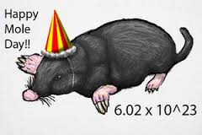
Unit # 6
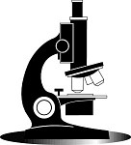
- Answer the questions each day during the first 10 minutes of class.
- If you are absent, you must make-up the missed questions the day you return.
Score
- Write the correct answers for any questions you missed.
- Turn in this assignment with your unit pack at the end of each unit.
 | Daily Warm-Ups:
Unit 6 Day 1 | Copy and fill in the following table:  Element/ion # of protons # of neutrons # of electrons  Cr  Mg⁺²  33 36  N⁻³  Uranium-235
Unit 6 Day 2 | - Convert the following:  A. 2.2 g of Al to moles B. 2.2 x10 ²² molecules water to moles  C. 55 g of C to atoms  - Find the molar mass of the following:  A. BaCl₂ B. Cu(NO₂)₂ C. aluminum sulfide  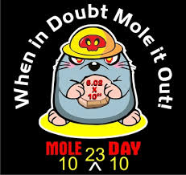
Unit 6 Day 3 | Given 35.1 g of Carbon dioxide gas (CO₂) convert to  - Moles B. molecules C. liters (at STP)  What is the percentage of sulfur in calcium sulfate (CaSO₄)?
Unit 6 Day 4 | Calculate the empirical formula of a compound that contains 1.67 g of Cerium, Ce and 4.54 g of iodine, I .  A compound is 53.3 % O and 46.7 % Si solve for the following information:  A. find its empirical formula B. If its molar mass is 180 g/mol what is it’s molecular formula?
Unit 6 Day 5 | Find the formula of a hydrate that is composed of 48.86 % Magnesium sulfate and 51.14 % water.

