**Atomic Structure 9/12 & 13/11**

***The Atom***

- Smallest particles of an element that ______________________________ the properties of that element

- Three main subatomic particles

- Proton

- Neutron

- Electron

***Subatomic Particles***

|  |  |  |  |  |
| --- | --- | --- | --- | --- |
| **Particle** | **Symbol** | **Charge** | **Relative Mass** | **Location** |
| **Electron** |  |  |  |  |
| **Proton** |  |  |  |  |
| **Neutron** |  |  |  |  |

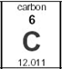***Distinguishing Atoms***

**- Atomic Number**

- Number of _______________________________ in the nucleus

- Determines the ____________________________

- Since atoms are ___________________________, the atomic number also tells us the number of

_________________________________ !

**- Mass Number**

- Number of protons ________________________ the number of _______________________________

Mass # =

- These are the two particles that really make up the _______________________ of the atom

**More on Mass**

- The mass of an atom comes from particles in *___________________________________*

*- The electron is sooooo small, we ignore its mass*

**Notation**

Oxygen - 15



***How to get Atomic and Mass #s***

- If you are ***not*** given the *atomic* number, simply look at the ________________________________________.

- If you are ***not*** given the *mass* number

- If have protons and neutrons, ________________ them

- If don’t have protons and neutrons, take the ___________________ from the periodic table and

_______________________to the nearest whole number

***Practice***

|  |  |  |  |  |  |  |  |
| --- | --- | --- | --- | --- | --- | --- | --- |
| **Name** | **Symbol** | **Atomic number** | **Mass Number** |  | **# of Protons** | **# of Neutrons** | **# of electrons** |
| **Sodium** |  |  |  |  |  |  |  |
|  | **Br** |  |  |  |  |  |  |

How many protons are there in Lithium-7? ________________

How many neutrons are there in Lithium-7? ________________

How many protons are there in Mg? ________________

How many electrons are there in Mg? ________________

How many neutrons are there in ? ________________

How many neutrons are there in Oxygen-18? ________________

***Isotopes***

- Atoms of the same element (same # of protons), but with different numbers of ___________________________.

- Have different ___________________ numbers (and ***masses***)

- Isotopes behave the _______________________ chemically because the still have the same number of protons and electrons

**Ex.** Isotopes of Neon

|  |  |  |  |
| --- | --- | --- | --- |
|  |  |  |  |
| **Protons** |  |  |  |
| **Electrons** |  |  |  |
| **Neutrons** |  |  |  |

***Ions***

- So far, we have focused on ***_________________________*** atoms

- Have an ***_________________________***number of protons and electrons

- We know the protons are tightly held in the nucleus

- Held there by ***__________________________*** forces

- Electrons are scattered outside the nucleus

- Less ***____________________________*** and able to change

- When an atom gains or loses electrons, it is called an _____________________

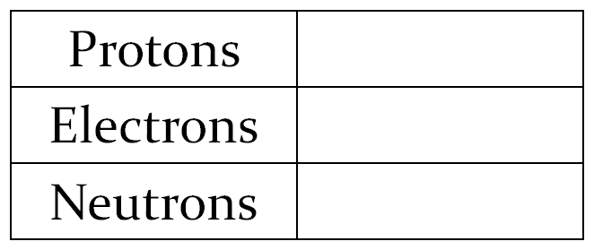

**Gain Electrons Ex.**

__________________________ charge

Called an _________________________



**Lose Electrons Ex.**

___________________________ charge

Called a ***_________________________***

***Summary of Changes to Subatomic Particles***

|  |  |
| --- | --- |
| ***Particle Changed*** | ***Result*** |
|  |  |
|  |  |
|  |  |

##### *Atomic Mass*

- The ***actual*** masses of protons, neutrons and electrons are all very _________________________

- Therefore, we compare the _________________________ masses of atoms

- All relative to a ____________________________ isotope as a standard

- Scientists picked ______________________________ as the reference isotopes

- Carbon-12 has a standardized mass of 12 amu (____________________ mass units)

***Average Atomic Mass*** – The _______________________________ average mass of the atoms in a _______________________________ occurring sample of the element

**have to take _______________________________ and their relative _____________________________ into account

Isotope Abundance Mass

Boron-10 19.0% 10 amu

Boron-11 81.0% 11 amu

**Ex.**

***Boron-10***: 0.190 x 10 =

***Boron-11:*** 0.810 x 11 = ___________________

**Ex.** What is the atomic mass of chlorine given the information below?

Isotope Abundance Mass

Chlorine-35 77.5% 35 amu

Chlorine-37 22.5% 37 amu